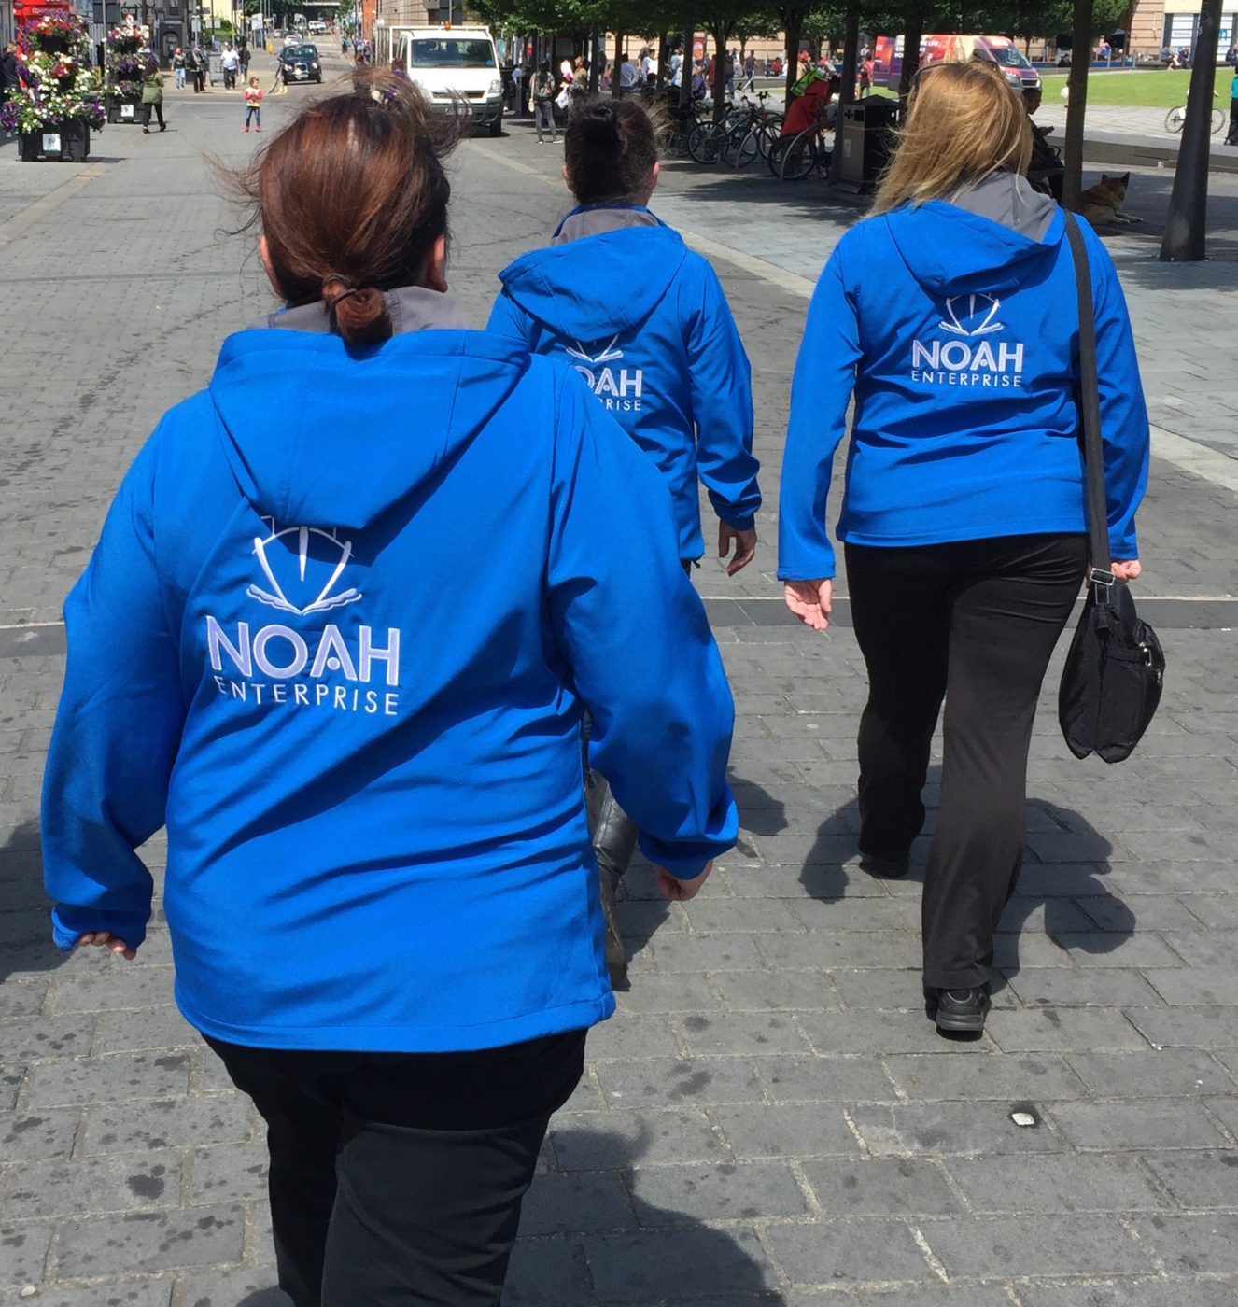

Application form is attached to the back, please remove and return to:

NOAH Volunteers

Community House (3rd floor)

15 New Bedford Road,

Luton, LU1 1SA

or email to:

[volunteering@noahenterprise.org](mailto:volunteering@noahenterprise.org)

Volunteering with NOAH

New Opportunities and Horizons

# About NOAH’s Work

NOAH is a charity that helps people experiencing homelessness, extreme poverty, and other disadvantages to make positive changes in their lives. We do this by providing care and advice services, training and wellbeing workshops, and opportunities for employment.

We are truly driven by our values of Care, Compassion, and Commitment, which have their roots in the teachings of Saint Vincent de Paul, whose life was the inspiration behind the founding of NOAH.

A Message from our CEO, David Morris:

*“Thank you for considering giving some of your time for the benefit of the most disadvantaged in our community. Quite simply, NOAH could not exist without our wonderful volunteers, and it is thanks to people like you that NOAH can help people in very difficult situations to make improvements in their lives.*

*Volunteering can be an incredibly rewarding experience. You may wish to support rough sleepers, deliver furniture to impoverished families, or work as one of our un-sung heroes behind the scenes! Whichever role you choose, you will be given a full induction, clear responsibilities and ongoing training and support.*

*NOAH are privileged to be able to work with truly inspirational people, every day. I hope that you will join our family of dedicated people and share in our vocation to provide practical help to those in most need of it.”*

# NOAH’s Values

NOAH’s values and ethos simply expressed are care, compassion, and commitment, and love for the people we work with and serve. Our values are practically expressed in humble service, helping those in need, in poverty and experiencing disadvantage and marginalisation.

In living out these values as an organisation, we prioritise recruiting trustees, staff and volunteers who are committed to and actively live out these values in contributing to the work of our teams.

# Volunteering Locations

WELFARE CENTRE

141 Park Street, Luton, LU1 3HG

**Open 365 days a year**

Our Welfare Centre is at the heart of NOAH Enterprise. It is from here that we offer a range of services according to the needs of the people we support. It is most often people's first encounter with NOAH and our priority is to gain their trust.

NOAH ACADEMY

Community House, 15 New Bedford Road, Luton LU1 1SA

CVS Centre, 43 Bromham Road, Bedford MK40 2AA

**Monday – Friday, 9.00 am – 5.00 pm**

NOAH Academy is a natural extension of our work with the homeless. Along with providing recreational activities and courses for our service users, it serves the wider community, providing an emphasis on helping those who are long term unemployed to re-enter the workplace. Courses run by the Academy include Digital Learning, Sewing skills, DIY skills, English for Beginners.

RETAIL STORES

Monday – Saturday 9.00 am – 5.00 pm

* 20-22 Hightown Road, Luton LU2 0DD
* 13 St Dominic’s Square, Tomlinson Avenue, Luton LU4 0UN
* 5 Wellington Street, Luton LU1 2QH

*“Volunteering with NOAH has been rewarding by allowing me to give back to the community” – Angie, Admin Volunteer*

# Volunteering with NOAH

Volunteers are essential to NOAH Enterprise and the work we do. Without volunteers we would be unable to continue offering the level of help and range of services we currently provide to some of the people who most need them.

All of our volunteer role profiles are available on our website, or you can request them from [volunteering@noahenterprise.org](mailto:volunteering@noahenterprise.org)

**Commitment**

We recognise that volunteers have different amounts of time that they offer us but even a regular commitment of one hour a week can be of great help. NOAH Volunteers assist in many ways and at different times across all sites - so we’re almost bound to have something to suit you!

As our volunteers are providing essential assistance to our services, we do ask that if you are unable to attend at any time that you let us know as soon as possible so that we make alternative arrangements.

Benefits

Volunteering with NOAH Enterprise is a worthwhile experience both for our service users and the volunteer, which is why many of our volunteers have been working with us for over five years - they enjoy it so much! As a volunteer you gain new skills & work experience, you make new friends and see for yourself how the work NOAH undertakes benefits lives and the community.

Other Ways to Help

* Donate money – contact the Fundraising team at [community@noahenterprise.org](mailto:community@noahenterprise.org) or see our website for further details
* Donations of good quality clothes, food, etc. are always welcome
* Legacies – If you’re thinking of writing a will or changing one, please remember NOAH Enterprise and why we are here, for the people on the streets. Contact [community@noahenterprise.org](mailto:community@noahenterprise.org) for more information



Thank you!

# What to do next if interested?

Complete the following application form and return to NOAH Volunteers, Community House (3rd floor), 15 New Bedford Road, Luton, LU1 1SA. Alternatively you can email it to: [volunteering@noahenterprise.org](mailto:volunteering@noahenterprise.org)

You can also complete the application form online at:

<https://noahenterprise.org/volunteer-form/>

Once we have received your form, a member of staff will be in contact with you to arrange a telephone interview to talk more about what opportunities NOAH Enterprise can offer you. This will also give you an opportunity to ask any questions you may have about being a volunteer with us. At this point you may be required to produce references on your character for us to contact, depending on the role you are applying for. Following this you will be asked to visit the project which you have applied to volunteer for, and to have an informal chat about your application. You will also be given a copy of our volunteer handbook to take away with you and read to familiarise yourself with our volunteer policies and procedures. During this stage the staff member will talk you through the key competencies of the role and fill all required paperwork. This will allow us to discuss all relevant training for your time volunteering with us.

On your first day of volunteering you will receive an induction covering everything from fire evacuation to where the amenities are located. You will also receive a full explanation of what your role entails and a training plan to support your development in the role. This training plan will be reviewed every three months with your assigned mentor to allow you to discuss your development at regular intervals.

We take the safety of our clients and staff very seriously, and carry out all DBS checks and safeguarding checks on applications as appropriate. Please be aware that we may reject an application for certain roles based on risk assessments at any point in the application process. If at any stage of the volunteering process you have any questions or concerns, please do not hesitate to contact us on the same details listed above.

Thank you for taking your time to consider volunteering with us.

*“I’ve loved working in the kitchens at NOAH, it has been a great way to give back to the community” – Annie, Kitchen Assistant*

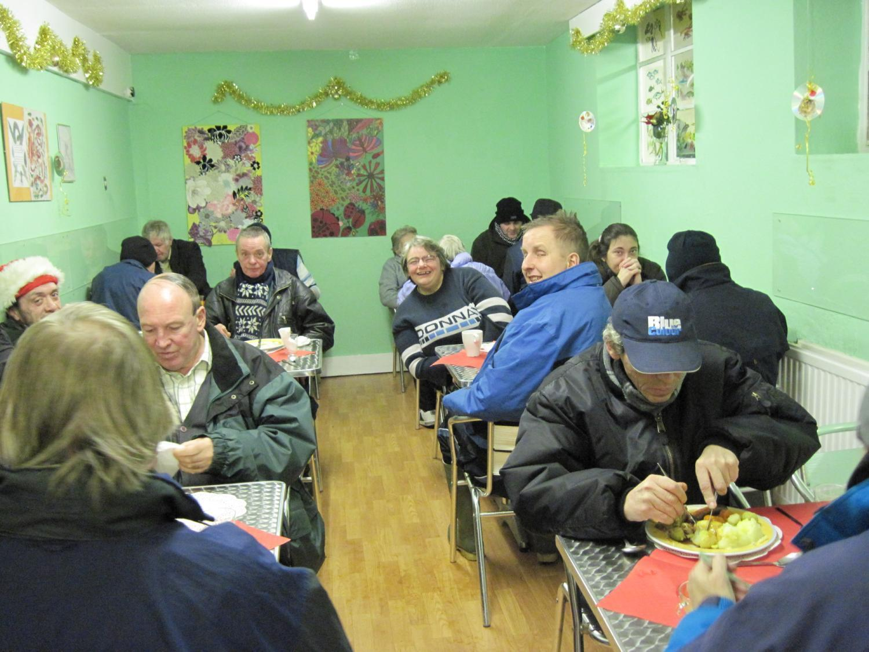

# A blue and black logo Description automatically generatedVolunteer Application

|  |  |  |  |  |  |  |
| --- | --- | --- | --- | --- | --- | --- |
| Personal Details | | | | | | |
| Title |  | First name | |  |  |  |
| Second name |  |  |  |  |  |  |
| Address and postcode |  |  |  |  |  |  |
| Telephone | Home: |  |  | Mobile: |  |  |
| Email |  |  |  |  |  |  |
| Age Requirement | | Are you over the age of 18? Yes / No | | | | |

|  |
| --- |
| How did you hear about us? |
| |  |  | | --- | --- | | NOAH Job Club  NOAH website  NOAH social media  Library  Job Centre Plus | NOAH Academy  NOAH Welfare Centre  Friend or relative  Other (please specify)_________________________ | |

|  |
| --- |
| Volunteer Role Profiles |
| Please tick the volunteer role profiles that you are interested in. All volunteer role profiles can be found on the NOAH website, or by contacting [volunteering@noahenterprise.org](mailto:volunteering@noahenterprise.org)   |  |  | | --- | --- | | Academy Assistant  Administration / Reception  Ambassador  Befriender  Cleaner  Community Fundraiser  Handy person / maintenance  Kitchen assistant  Other – please specify______________________ | Marketing assistant  Outreach worker  Placement counsellor (for LST students only)  Stock / warehouse assistant  Store assistant  Van driver  Van driver’s assistant  Welfare centre support assistant | |

|  |
| --- |
| Locations |
| If you have a preferred location/s, please select below.   |  |  | | --- | --- | | Welfare Centre, Park Street  Academy – Luton  Academy - Bedford | Store – Hightown Road  Store – Lewsey Farm  Store – Wellington Street | |

|  |
| --- |
| What is your motivation for volunteering with us? (tick all that apply) |
| |  |  | | --- | --- | | Improve my CV  Give something back and help the community  Do something positive with my time  Develop a personal interest or hobby  Share my skills, knowledge or expertise | Build my confidence  Gain experience  Socialise and meet new people  Try something new  Learn new skills  Other (please specify)_______________________ | |

|  |  |  |  |  |  |  |  |
| --- | --- | --- | --- | --- | --- | --- | --- |
| Your Availability | | | | | | | |
| TIMES AVAILABLE | MON | TUE | WED | THU | FRI | SAT | SUN |
| MORNING |  |  |  |  |  |  |  |
| AFTERNOON |  |  |  |  |  |  |  |
| EVENING |  |  |  |  |  |  |  |

|  |
| --- |
| Your Skills & Experience |
| Please briefly describe any paid or unpaid work, educational, or life experience that you feel you  could bring to the volunteer role you are applying for with NOAH Enterprise |
|  |

|  |
| --- |
| Disclosure & Barring Service check (DBS) |
| If you are offered a role at NOAH Enterprise, you may be asked to obtain a DBS check which  NOAH will arrange for you. Please note that a conviction will not necessarily mean that you  cannot volunteer with us.  Volunteers who are eligible for a DBS check must disclose any criminal convictions which occur during their time with NOAH (including motoring offences if they use a company vehicle or are required to use a private vehicle on behalf of NOAH). A failure to disclose a criminal conviction, or if as a result of a police investigation into an volunteer’s conduct, or criminal charges are brought against a volunteer which may cause or causes reputational damage to NOAH, the volunteer may be unable to continue working with NOAH. |
| Do you have any unspent conditional cautions or convictions under the Rehabilitation of  Offenders Act 1974? Yes / No  Do you have any adult cautions (simple or conditional) or spent convictions that are not  protected as defined by the Rehabilitation of Offenders Act (Exceptions) Order 1975  (Amendment) (England and Wales) Order 2020? Yes / No  *Please be aware that you may be required to undergo an enhanced DBS check for the position you are applying for upon*  *being accepted.* |

|  |  |
| --- | --- |
| Emergency Contact Details | |
| Please provide details of an individual to be contacted in the case of any situation arising whilst undertaking your volunteering | |
| Name: | |
| Telephone Number: | Relationship to yourself: |
| Please sign to confirm you have been granted permission by the individual for us to store their contact information on our systems: _____________________________ | |

|  |  |
| --- | --- |
| Declaration | |
| I declare that, to the best of my knowledge and belief, the information given on this application form and supplied with it, is correct. | |
| Signed | Date |

|  |
| --- |
| The details from this form will be stored and processed in alignment with NOAH’s privacy policy. For further details, our privacy policy can be found on NOAH’s website.  Please confirm that you agree to NOAH Enterprise storing your details on our computerised system.  YES / NO |

|  |
| --- |
| Equal Opportunities Monitoring |
| **Gender**  Female  Male  Transgender female  Transgender male  Non-binary  A gender not listed here, please specify:………………………………………………………………………….  **Sexual orientation?**  Heterosexual ☐ Gay ☐ Lesbian ☐ Bisexual ☐ Prefer not to say ☐  A term not listed here, please specify:……………………………………………………………………………..    **Age** 16-24 25-29  30-34  35-39 40-44  45-49  50-54 55-59  60-64  65+  Prefer not to say  **What is your ethnicity?**  Ethnic origin is not about nationality, place of birth or citizenship. It is about the group to which you perceive you belong. Please tick the appropriate box  ***White***  English ☐ Welsh ☐ Scottish ☐ Northern Irish ☐ Irish☐ British ☐ Gypsy or Irish Traveller☐ Prefer not to say ☐  Any other white background, please specify:………………………………………………………………..  ***Mixed/multiple ethnic groups***  White and Black Caribbean ☐ White and Black African ☐ White and Asian ☐ Prefer not to say ☐  Any other mixed background, please specify:……………………………………………….…………………  ***Asian/Asian British***  Indian ☐ Pakistani ☐ Bangladeshi ☐ Chinese ☐ Prefer not to say ☐  Any other Asian background, please specify:…………………………………………………………………..  ***Black/ African/ Caribbean/ Black British***  African ☐ Caribbean ☐ Prefer not to say ☐  Any other Black/African/Caribbean background, please specify:………………………………………..  ***Another ethnic group***  Arab ☐ Prefer not to say ☐  Any other ethnic group, please specify:…………………………………………………………………………..  **What is your religion or belief?**  No religion or belief ☐ Buddhist ☐ Christian ☐ Hindu ☐ Jewish ☐ Muslim ☐ Sikh ☐ Prefer not to say ☐  If other religion or belief, please specify:………………………………………………………………………….  Do you consider yourself to have a disability or health condition?  Yes **☐** No ☐ Prefer not to say ☐  If you would like us to make any adaptations to accommodate any disability or condition you may have, please tell us what these should be: |

*These pages (9 and 10) will be removed from the application before the application is handed over to the individual in charge of volunteer allocation. Therefore, the information contained on this section of the form will not influence whether or not you will get allocated to volunteer with us.*